CN ASSIGNMENT 1 (from ex:3.4)

## 

**Eisha Tir Raazia**

**17K-3730**

**Section C**

Answer of Q.No.1 Sequence number needed to be introduced to identify/determine whether the packet which is being sent is retransmission or a new packet. Therefore, the sequence numbers provide information about the packets that are dropped and supports reordering.

Answer of Q.No.2 Timers help to recognize if a packet is lost or it is received as, if the acknowledgement for a sent packet is not received within the timer duration of packet(timeout) then it is assumed that the packet is lost due to any reason and then it is retransmitted by the packet sender.

Answer of Q.No.3 Even if the round trip delay is constant, the timer will still be necessary and useful in order to detect the packet loss. And sender can create an estimation error which can consequently lead to duplicate transmissions in case of for prematurely expired timers. Only advantage of knowing the RTT is that sender knows/can make a good estimation that either the packet or its acknowledgement has been lost.

Answer of Q.No.4 **(Animation for Go-back-N)**

(a) Sending 5 packets and killing the first before it reaches the receiver end

* None of the packets were acknowledged when first packet was found lost.

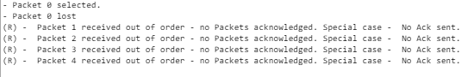

* ACK was sent to the sender when retransmitted packets were received again and all the packets in the frame along with the lost packet were sent again..

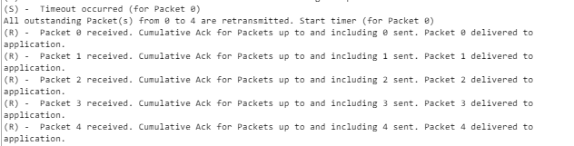

(b) Five packets are received on the other end but we kill the first acknowledgment. Describe what happens now?

* ACK was sent to the sender but the timers of the packets were stopped

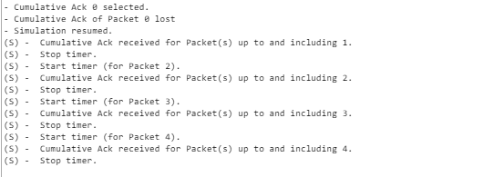

(c) Trying to send the 6 packets simultaneously

First 5 packets were sent first, and 6th was sent when 1st packet's acknowledgement was received.

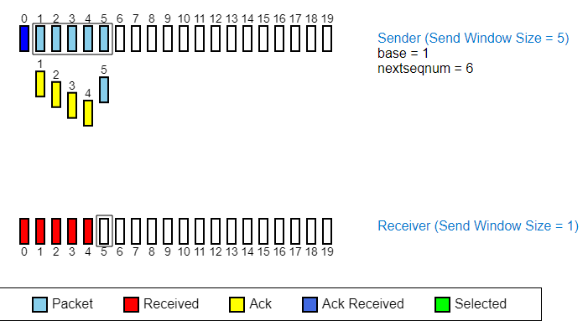

Answer of Q.No.5 **(Animation for Selective Repeat)**

(a) Sending 5 packets and killing the first before it reaches the receiver end

* Acknowledgement of all the packets except the lost packet were sent to the sender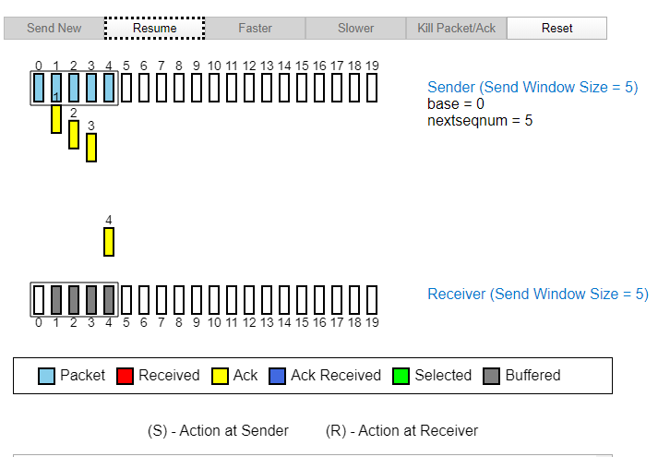
* Then then lost packet was sent again, until then the 'received' status wasn't updated for any packet in frame and they were buffered on receiver end.

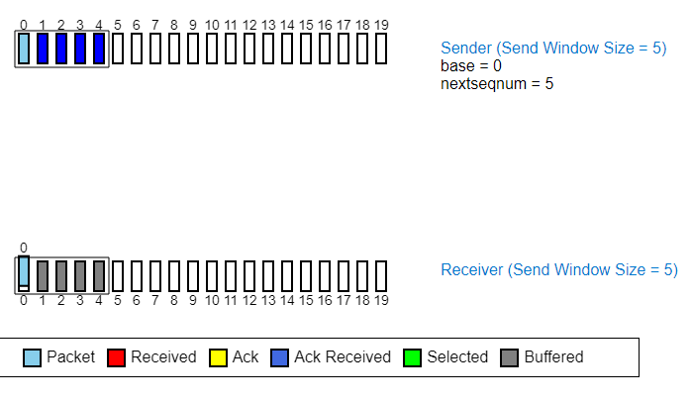

* When lost packet was received, all the buffered packets were delivered to application, and 1st packet was acknowledged too.

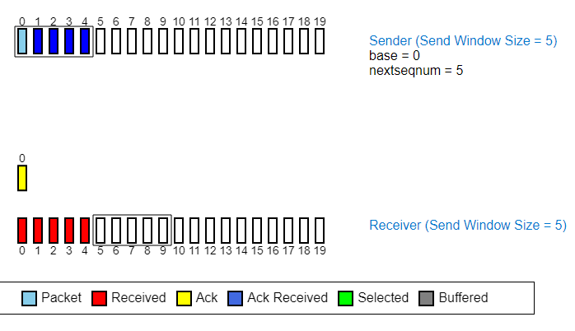

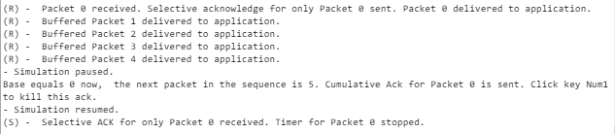

(b) Five packets are received on the other end but we kill the first acknowledgment. Describe what happens now?

* When acknowledgement of 1st packet was lost then 1st packet was sent again after receiving acknowledgement for rest of the packets.(packet duplication)

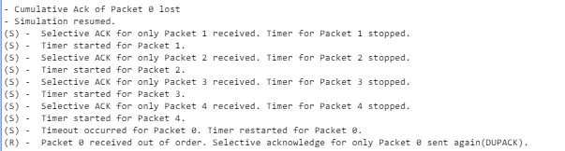

(c) Trying to send the 6 packets simultaneously

* First 5 packets were sent first, and 6th was sent when 1st packet's acknowledgement was received.

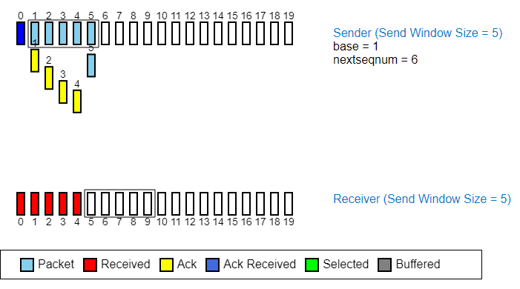

Main difference between the Go-back-n & Selective repeat

**The major difference found between the two protocols (Go-back-N & Selective repeat) is that the Go-back-n protocol(GBN) retransmits all the packets that lie after the one which is lost or is damaged (this is illustrated in the above screenshots of animation) while in the case of Selective repeat protocol(SR), only the lost packet is retransmitted while other packets are received, send their acknowledgement and remain buffered until lost packet is received.**